**Manual for WW-ADCP analysis Matlab code**

**Bofu Zheng**

**boz080@ucsd.edu**

1. Open function ‘process_WW_ADCP_main.m’
2. Set up file paths for different products

1. Set up variables used for analysis, according to ADCP’s configuration

1. Sort files. Sometimes raw .mat files are not in time sequences, therefore, this function is to sort them according to time and will help with further combination

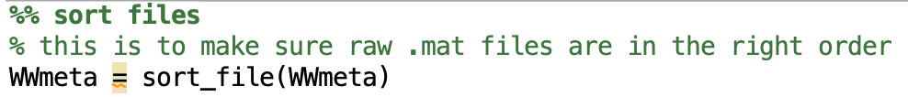

1. Combine raw .mat files and chunk into up/down casts. Here, note that if you defined a figure path (figpath) in the previous set path section, then a figure showing up/down cast separation will be saved everyone ‘create_profiles.m’ function is run. Also the ‘thhold’ value may vary with WW deployments, so remember to adjust this value.

1. Combine cut-off profiles

1. WW – ADCP analysis. This function follows the analysis procedures described in Zheng et al., 2021, which basically includes WW motion correction and a box-averaging technique. An updated version is used for upward looking adcps (WWvel_upward) with additions by Devon Northcott. This includes shear calculated from raw data and binned, and box averaged amplitudes and Nav variables. It also takes instrument tilts into account by interpolating beam data onto an even depth grid before earth velocities are formed. Use this version upward looking and slightly tilted ADCPs.Text, letter

   Description automatically generated
2. Take a quick look

